
Dashboard Design
Date | 21 September 2026
Team ID | MCA
Project Name | Strategic Employee Attrition Intelligence Dashboard
Maximum Marks | 5 Marks

The dashboard follows a clear and structured design with KPI cards, charts, filters, and a consistent colour theme. Interactive slicers for Work Mode, Department, and Job Role help users explore attrition patterns. Appropriate bar charts and KPI visuals are used to present employee data clearly, while drill-down and interactive features support detailed workforce analysis.

Activity 1: Interactive and visually appealing dashboards
The Strategic Workforce Analysis and Attrition Insights dashboard was designed using Power BI to provide a clear and interactive view of employee attrition and workforce factors
Dashboard Design Principel | Implementation in the Dashboard
Clear and Intuitive Layout | The dashboard uses a structured layout with KPI cards at the top and charts arranged below for easy understanding.
Use Appropriate Visualizations | Bar charts, KPI cards, and comparison visuals are used to display employee attrition, job roles, departments, and employee factors.
Colour and Theming | A consistent blue-based colour theme is used throughout the dashboard to provide a professional and uniform appearance.
Interactive Filters and Slicers | Filters for Work Mode, Department, and Job Role allow users to view specific employee groups and analyze attrition patterns.
Drill-Down Capabilities | Users can explore workforce information at different levels, such as department, job role, and work mode, to understand detailed attrition patterns.
Responsive Design | Visuals and KPI cards are arranged neatly so that important information can be viewed easily without unnecessary clutter.
Custom Visuals and Icons | KPI cards and formatted visual elements are used to highlight important workforce metrics such as total employees and attrition rate.
Use of Infographics | KPI cards and graphical charts provide a visual summary of employee count, attrition, average tenure, AI adoption, and other workforce insights.

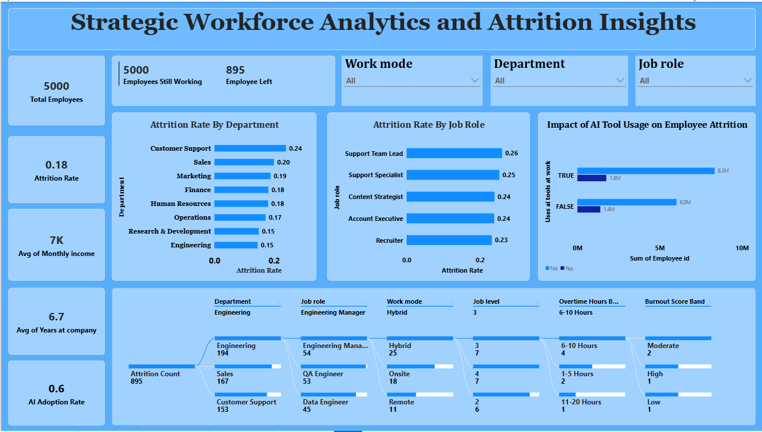
- Overall Attrition & Retention Volume: The company maintains a workforce of 5,000 total employees, of which 5,000 are currently working while 895 employees have left.
- Overall Attrition Rate & Company Tenure: The baseline attrition rate across the organization stands at 0.18 (18%), with employees averaging a tenure of 6.7 years at the company.
- Departmental Attrition Distribution: Customer Support experiences the highest rate of attrition at 0.24, followed closely by Sales at 0.20, whereas Engineering and R&D maintain the lowest attrition rates at 0.15.
- Role-Specific Attrition Vulnerability: Attrition peaks in leadership and specialist positions, with Support Team Leads reaching the highest rate at 0.26, followed by Support Specialists at 0.25.
- AI Tool Adoption Level: The organization shows a overall AI adoption rate of 0.6 (60%) across its workforce.
- Engineering Department Breakdown: Out of the 895 total departing employees, Engineering accounts for the largest share at 194, where Engineering Managers on a Hybrid work mode are the primary contributor.

